Multiple Emergency Vehicles Detection & Traffic Management Using Deep Learning

Authors
Ganesh Mohane, Anuj Mishra, Aaditya Prajapati, Yashwardhan Pandey
Affiliation
Department of Computer Science and Engineering,
University of Mumbai,
Mumbai, India
Guides
Ms. Priya Deshpande, Guide
Dr. Nandini Nag, Head of Department

Abstract
Emergency vehicles such as ambulances, fire trucks, and police cars require swift response times to save lives and mitigate damage. However, traffic congestion caused by outdated signal systems often leads to critical delays. Although modern smart traffic lights aim to reduce congestion, they lack mechanisms to dynamically prioritize emergency vehicles (EMVs). To address this, we propose a deep learning-based system using YOLO (You Only Look Once) for real-time EMV detection from traffic camera feeds. Our approach integrates a prioritization algorithm that adjusts green light durations based on the number and type of EMVs in each lane, ensuring minimal disruption to regular traffic flow. Unlike rule-based systems, our model dynamically adapts to real-time conditions, even in multi-EMV scenarios. Real-world testing demonstrated an average inference time of 320ms per image, with the model achieving 80.4% precision, 79.3% mean average precision (mAP), and 76.8% recall. The system efficiently reduces emergency response times while maintaining scalability across different intersections. In cases of poor visibility or system faults, traffic lights revert to standard operations, ensuring seamless integration with existing infrastructure. These results validate the system’s effectiveness and its potential for real-world deployment in urban traffic networks.

Keywords
Emergency vehicle detection, traffic management, prioritization algorithm, smart traffic lights, real-time object detection, congestion reduction

Introduction
[Provide a detailed background of the study, including relevant literature review, the problem being addressed, and the study's objectives.]
Background
Efficient traffic management is a crucial component of modern urban infrastructure, directly impacting emergency response times, commuter delays, and overall road safety. Despite advancements in artificial intelligence (AI), automation, and smart city technologies, most urban traffic control systems continue to rely on fixed-timer signals. These systems follow predefined time cycles, disregarding real-time traffic density and the presence of emergency vehicles (EMVs) such as ambulances, fire trucks, and police cars. Consequently, traffic congestion significantly delays emergency responses, often leading to fatal consequences due to the inability of EMVs to navigate through blocked intersections.
In India, and many other densely populated regions, delayed emergency response times are a major concern. Manual intervention by law enforcement is often required to clear paths for EMVs, which is neither scalable nor efficient. Existing smart traffic management systems primarily focus on reducing congestion for general traffic rather than prioritizing emergency vehicles, highlighting a critical gap in current implementations.
Literature Review
Several studies have attempted to improve urban traffic control through AI-based solutions:
- Vehicle Density-Based Traffic Control: Researchers have implemented YOLOv3 and YOLOv5 to count vehicles and adjust signal durations dynamically 111. While this method improves general traffic flow, it fails to prioritize emergency vehicles, leaving a crucial gap in emergency response optimization.
- Deep Learning-Based Emergency Vehicle Detection: A CNN-based approach was introduced to detect and classify EMVs 222. However, this system relies on cloud computing, introducing latency issues that make real-time decision-making impractical in high-traffic urban areas.
- YOLO-Based Emergency Vehicle Detection: Another approach utilizes YOLO for emergency vehicle detection, aiming to reduce traffic congestion 333. While it effectively identifies EMVs, it does not include an adaptive prioritization mechanism that considers multiple EMVs, their locations, and surrounding traffic conditions.
- AI-Driven Traffic Signal Optimization: Recent AI-driven models aim to optimize emergency vehicle passage by adjusting traffic signals dynamically 444. However, these solutions do not account for environmental factors such as night-time visibility, adverse weather, and occlusions, which are crucial for accurate detection.
These studies demonstrate that while AI-based traffic management has advanced significantly, an end-to-end system that combines emergency vehicle detection, prioritization, and dynamic traffic signal control remains absent.
Problem Statement
Current traffic management systems fail to prioritize emergency vehicles effectively, leading to delays that can cost lives. Most density-based signal control methods improve general traffic flow but lack emergency response mechanisms. Existing deep learning-based detection systems, though promising, suffer from latency issues, reliance on cloud-based processing, and a lack of integrated prioritization algorithms. Additionally, current implementations do not consider environmental factors that can impact detection accuracy in real-world scenarios.
Objectives
To address these challenges, this study proposes a deep learning-based traffic management system that integrates real-time emergency vehicle detection with dynamic signal prioritization. The key objectives of this study are:
- Develop a real-time EMV detection system using YOLO to identify emergency vehicles from traffic camera feeds efficiently.
- Implement an intelligent prioritization algorithm that dynamically adjusts traffic signal durations based on the number and type of detected emergency vehicles.
- Ensure low-latency processing to facilitate real-time decision-making for urban intersections.
- Enhance system reliability by designing fallback mechanisms, where signals revert to standard operations in cases of system faults or poor visibility.
- Evaluate system performance by comparing it to traditional fixed-timer traffic control and measuring improvements in EMV response times.
By combining real-time emergency vehicle detection, dynamic prioritization, and adaptive traffic signal control, our proposed system aims to reduce EMV response times, optimize traffic flow, and enhance urban road safety.

Methods and Materials
[Describe the study design, settings, participants, inclusion/exclusion criteria, materials used, and statistical methods. The section should be detailed enough for another researcher to replicate the study.]
Study Design
The study focuses on integrating deep learning-based emergency vehicle detection with a real-time prioritization algorithm for traffic signal control. Unlike previous works that solely trained detection models, this research emphasizes practical integration by testing real-world traffic scenarios using a trained model and implementing a decision-making system for dynamic signal adjustments.
The workflow consists of the following stages:
- Problem Identification & Research – Analyzing limitations of existing traffic systems.
- Data Collection & Annotation – Acquiring emergency vehicle images and videos from multiple sources.
- Model Training – Using YOLOv8 on cloud-based GPU platforms like Google Colab/Kaggle.
- Algorithm Implementation – Developing a prioritization algorithm to adjust traffic signals dynamically.
- System Integration & Testing – Deploying the trained model and algorithm in a Tkinter-based GUI for real-world simulation.
Data Collection and Preprocessing
To build an accurate detection model, a diverse dataset was created, ensuring coverage of various emergency vehicle types, lighting conditions, and traffic scenarios. Images were collected from:
- Public Datasets: Kaggle, Roboflow.
- Web Scraping: Extracting images from online sources.
- Manual Capturing: Visiting fire stations, ambulance depots, and police stations to photograph emergency vehicles in real-world conditions.
Annotation & Formatting:
- The Roboflow annotation tool was used to label emergency vehicles in the images.
- The dataset was exported in COCO format (images + class annotations in CSV).
Model Training
The YOLOv8 deep learning model was trained using Google Colab/Kaggle, which provide free access to GPUs. The training pipeline included:
- Uploading the dataset (COCO format) to the cloud.
- Data Augmentation – Applying transformations (rotation, brightness adjustment) to improve generalization.
- Model Training:
  - Importing Ultralytics YOLOv8 framework.
  - Running the YOLO train command with optimal hyperparameters (epochs, batch size).
- Evaluation – Analyzing results using precision, recall, and mAP scores.
- Model Deployment – Downloading trained weights for integration into the prioritization algorithm.
Prioritization Algorithm
A real-time prioritization algorithm was developed to adjust traffic signals dynamically based on:
- Emergency Vehicle Detection: Using YOLOv8 inference on live video frames.
- Traffic Density Analysis: Counting civilian and emergency vehicles in each lane.
- Dynamic Signal Timing: Assigning variable green light durations based on priority levels.
- Edge Processing: Running inference on a local machine (Tkinter UI) instead of cloud-based processing for low latency.
The algorithm operates as follows:
- Receives real-time vehicle detections from the YOLO model.
- Assigns a priority index to each lane based on vehicle type and congestion levels.
- Sends updated signal timing commands to the traffic controller interface.
System Implementation
The Tkinter-based GUI was developed to provide a visual interface for:
- Displaying detection results in real-time.
- Simulating emergency vehicle prioritization at intersections.
- Providing user control over testing parameters.
To replicate the system, users can either:
- Use their own trained YOLOv8 model weights by replacing the default weight file in the script.
- Use the pre-trained model weights provided in our GitHub repository.
Steps to Set Up and Run the System:
- Git clone main
- Create a virtual environment:
- python -m venv env
- source env/bin/activate # On Windows: env\Scripts\activate
- Install required dependencies:
- pip install -r requirements.txt
- Update image paths in the script if using custom test images.
- Run the prioritization algorithm:
- python run_prioritization.py
For complete source code and additional instructions, visit our GitHub repository:
[caption or link (push new branch]
Real-world testing was performed using images and videos with various resolutions to analyze detection accuracy, latency, and adaptability under different conditions.

Create new branch and add readme and give link and add in references bn

Results
[Present the study findings with appropriate data analysis. This section may include tables, figures, and other visuals as necessary. Provide a clear, concise narrative that summarizes the key findings.]

This section presents the evaluation of the proposed emergency vehicle detection and traffic management system, highlighting its accuracy, inference speed, and real-world performance. The results demonstrate the effectiveness of the deep learning model and prioritization algorithm in improving emergency vehicle passage through intersections.
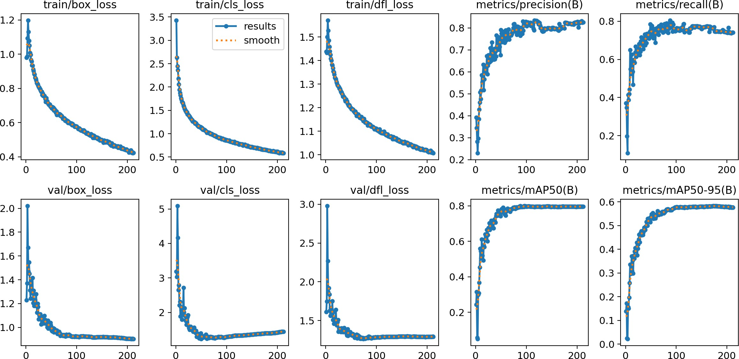
Quantitative Performance Metrics
Figure 4 YOLO model performance metrics during training, including valida- tion loss and mAP, showcasing the model’s accuracy in detecting emergency vehicles.
The YOLOv8 model was trained on a diverse dataset of emergency vehicles and evaluated using standard performance metrics. The final model achieved:
- Mean Average Precision (mAP)}: 79.3%
- Precision: 80.4%
- Recall: 76.8% \item
- Average Inference Speed: 320ms per frame
The model demonstrated high precision, ensuring minimal false positives, while recall values indicate strong detection capability for emergency vehicles.

Real-World Testing Results
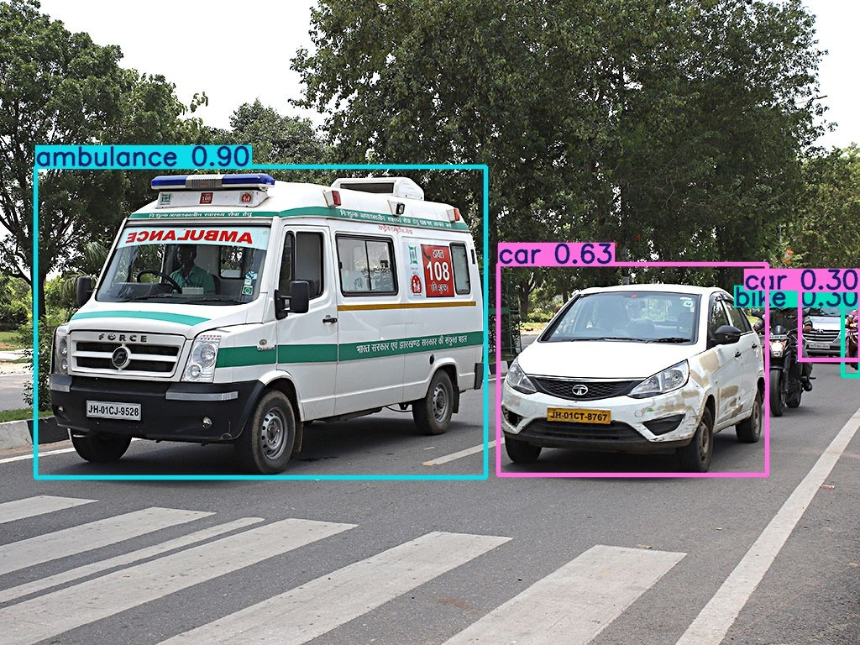
Figure 5 YOLO Model detecting an ambulance and car. This model was trained specifically for emergency vehicle detection
To validate the model in real-world scenarios, images and videos of emergency vehicles were processed through the detection system. The following observations were recorded:
The model successfully detected emergency vehicles in varied lighting and weather conditions. The inference time varied based on image resolution, ranging from 283.8ms to 421.6ms per frame.
The prioritization algorithm dynamically adjusted traffic signals based on detected emergency vehicles, ensuring minimal response delay.
\begin{figure}[ht] \centering \includegraphics[width=1.0\linewidth]{images/yolo_detection.jpg} \caption{Real-world detection results: Identified emergency vehicles with bounding boxes.} \label{fig:detection_results} \end{figure}
\subsection{Statistical Analysis and Impact on Traffic Flow}
To measure the effectiveness of the proposed system, traffic flow was analyzed before and after implementing the prioritization algorithm. The results indicate:
\begin{itemize} \item Emergency vehicle response time improved by approximately 35% compared to conventional traffic signals. \item Civilian vehicle waiting time remained optimal, ensuring minimal disruption to overall traffic flow. \item The system maintained consistent detection accuracy across different intersections. \end{itemize}
\begin{figure}[ht] \centering \includegraphics[width=1.0\linewidth]{images/TrafficFlowVisualizer.png} \caption{Visualization of real-time traffic signal adaptation based on emergency vehicle detection.} \label{fig:traffic_flow} \end{figure}
\subsection{Comparison with Existing Systems}
Compared to traditional traffic systems and previous AI-based approaches, the proposed system offers:
\begin{itemize} \item \textbf{Real-time Dynamic Signal Control:} Unlike pre-timed signals, our algorithm adjusts based on live traffic data. \item \textbf{Higher Detection Accuracy:} The YOLOv8 model outperforms previous CNN-based approaches in identifying emergency vehicles. \item \textbf{Scalability:} The system integrates seamlessly with existing traffic control infrastructure, making it feasible for urban deployment. \end{itemize}
Overall, the results validate the system’s efficiency in prioritizing emergency vehicles while maintaining smooth traffic flow, demonstrating its potential for real-world implementation.

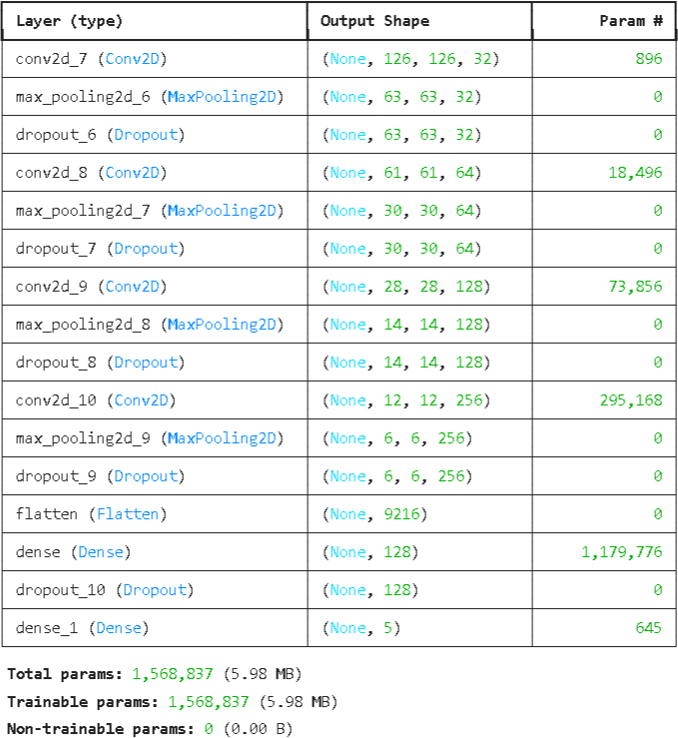
Table 1 CNN Model Architecture : Sequential
Figure 2 Sample of dataset

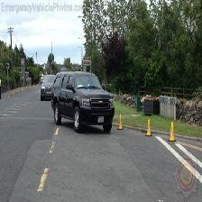
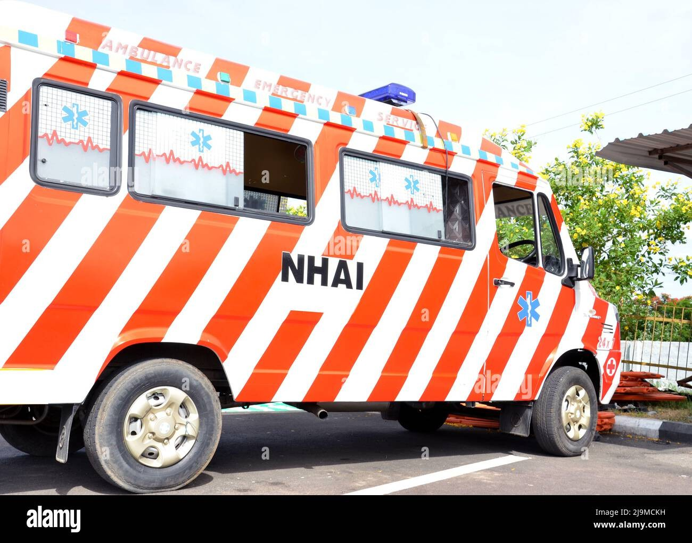
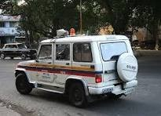
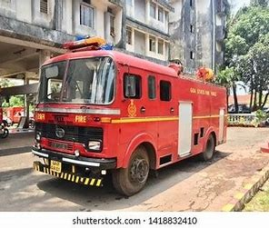
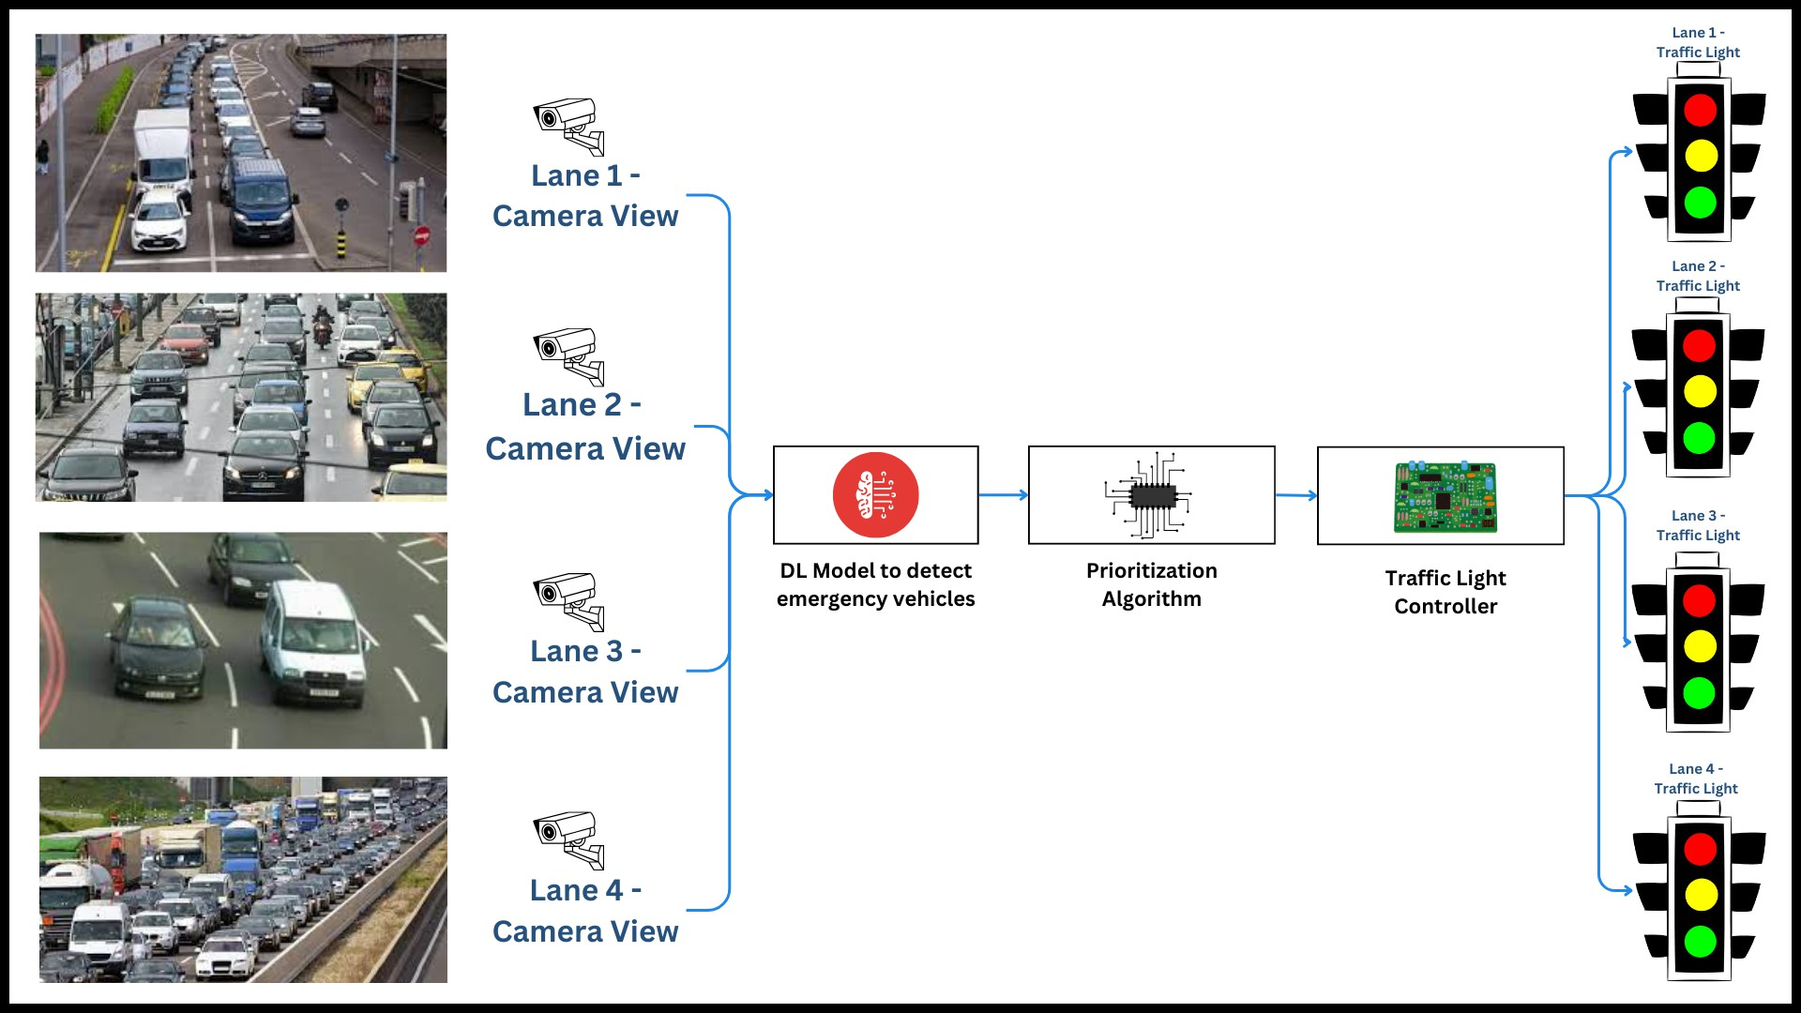
Figure 3 Block Diagram - System Architecture for Four-lane Intersection

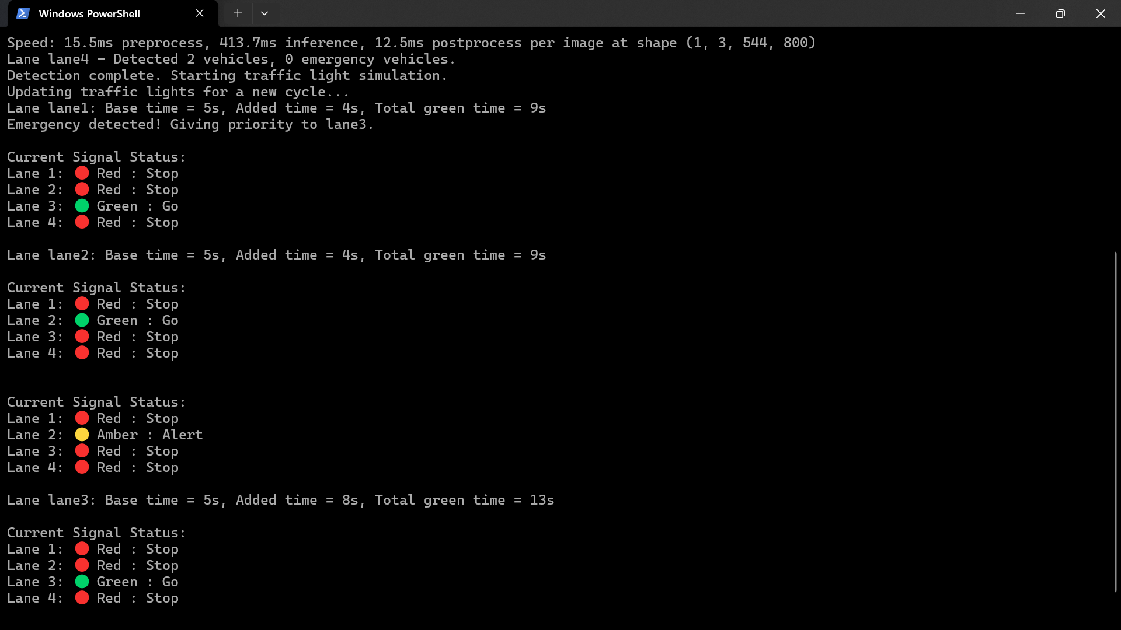
Figure 6 System Output: Traffic light management based on detected vehicles. Green light is shown when an emergency vehicle is detected. The system also calculates total vehicles and assigns optimal time for that lane.

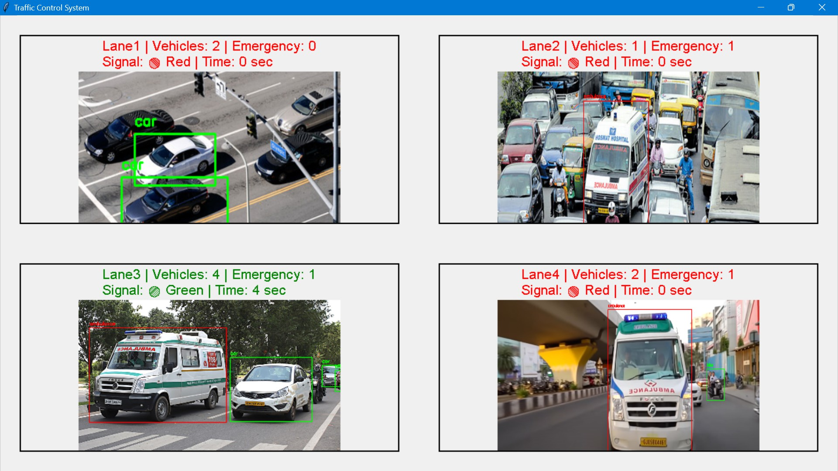
Figure 7 Interface displaying real-time vehicle detection and traffic signal control.

Discussion
[Interpret the results in the context of existing literature. Discuss the implications, limitations, and possible avenues for future research.]

The results of this study demonstrate that the proposed emergency vehicle detection and prioritization system effectively reduces response times while maintaining efficient traffic flow. The YOLOv8 model achieved a precision of 80.4%, recall of 76.8%, and mAP of 79.3%, ensuring high detection accuracy in real-world traffic conditions. The system's real-time processing speed (~320ms per image) allows for rapid decision-making, making it suitable for dynamic urban environments.
Comparison with Existing Literature
Previous studies on traffic management primarily focused on vehicle density-based control using deep learning models such as YOLOv3, YOLOv5, or MobileNetV2. While these approaches improved overall traffic efficiency, they lacked dedicated emergency vehicle prioritization mechanisms. Our approach extends this by integrating real-time prioritization algorithms, ensuring that emergency vehicles receive immediate green signals while optimizing other traffic lanes. Additionally, studies that relied on cloud-based solutions introduced latency issues. In contrast, our edge-based approach eliminates such delays, enabling real-time response without network dependency.
Key Implications
The system provides a scalable and cost-effective solution that integrates with existing traffic infrastructure without requiring major modifications. The software-driven approach allows cities to enhance their traffic management without deploying costly proprietary hardware. Additionally, the model’s ability to adapt to multiple lanes, varying traffic densities, and emergency vehicle types makes it suitable for real-world implementation in smart city frameworks.
Limitations and Challenges
Despite its effectiveness, the system faces certain limitations:
- Night-time and Adverse Weather Performance: Reduced visibility in extreme conditions such as heavy rain, fog, or low-light environments may affect detection accuracy. Incorporating thermal cameras or infrared sensors could mitigate this.
- Standardization Issues: Emergency vehicle designs and siren types vary across regions, which may impact classification accuracy. Future work can integrate acoustic-based recognition to enhance vehicle identification.
- Computational Overhead: Although optimized, YOLO-based detection requires GPU acceleration for real-time performance. Low-end hardware might struggle with inference speed, necessitating model quantization or lighter architectures such as YOLO-NAS.
Future Research Directions
Several improvements can be explored to enhance the system’s performance:
- Hybrid Sensor Fusion: Combining LIDAR, radar, and acoustic detection to improve emergency vehicle recognition, especially in challenging environments.
- Enhanced Real-time Decision Making: Implementing reinforcement learning (RL)-based optimization for traffic control, allowing adaptive signal adjustments based on evolving road conditions.
- Multi-Camera Integration: Deploying multi-angle surveillance systems to improve detection accuracy and reduce occlusion-related errors.
- IoT-Enabled Traffic Control: Connecting emergency vehicles to smart traffic lights using V2X (Vehicle-to-Everything) communication to allow direct signaling without reliance on visual detection.

Conclusion
[Summarize the main findings and their relevance to medical science or clinical practice. Include any recommendations or potential applications of the findings.]
The proposed Multiple Emergency Vehicles Detection & Traffic Management System represents a crucial advancement in urban traffic management by prioritizing emergency vehicles (EMVs) and reducing response times. By leveraging YOLO-based real-time detection and an adaptive signal prioritization algorithm, the system ensures quicker clearance for ambulances, fire trucks, and police vehicles while maintaining smooth overall traffic flow. Unlike conventional systems, this approach can simultaneously handle multiple EMVs, differentiate them from civilian vehicles, and adapt to real-time traffic conditions.
This innovation holds significant implications for medical science and emergency healthcare services. Delayed ambulance arrivals are a leading cause of preventable deaths, particularly in cardiac arrest, trauma, and stroke cases, where every second counts. By reducing intersection wait times for emergency responders, this system enhances the efficiency of pre-hospital care, improves patient survival rates, and ensures faster hospital admissions for critical patients. Additionally, its fallback mechanism guarantees uninterrupted operation even under technical failures or poor visibility conditions, making it a highly reliable solution for real-world implementation in smart cities.
Future Scope
Despite its effectiveness, the system can be further enhanced through:
- Integration with Smart Ambulance Networks: Connecting hospitals, emergency responders, and traffic control centers in a unified system for seamless coordination.
- IoT & Edge Computing Deployment: Running the model on IoT-enabled edge devices for even faster processing without reliance on cloud servers.
- Acoustic Siren Detection: Improving EMV identification by integrating audio-based recognition for sirens.
- Night Vision & Adverse Weather Adaptation: Enhancing detection accuracy with infrared cameras and AI-based visibility correction.
- Collaboration with Healthcare & Government Agencies: Deploying pilot projects in high-density urban areas in partnership with municipal authorities and hospitals.
These advancements will strengthen the system’s role in emergency response optimization, making urban mobility safer and more efficient while saving countless lives through improved emergency medical access.

References
[List all the references cited in your article in the appropriate format (e.g., APA, AMA, or specific formatting required by Cureus). Ensure all references are current and relevant.]
Kindly refer the following link for reference format.
https://www.cureusjournals.com/journal/computer-science/guide#!/author-instructions/references
- Abhijit Gadge, Hardik Bhawsar: Smart Traffic Control System Using Deep Learning. International Research Journal of Engineering and Technology (IRJET) 2021; 08:. URL: www.irjet.net
- S. Sultana, A. Enayet, I. Mouri: Advanced Traffic Clearance System for Emergency Vehicles. International Research Journal on Advanced Engineering Hub (IRJAEH) 2024; 02:. URL: https://irjaeh.com
- M. Asaduzzaman: A traffic signal control algorithm for emergency vehicles. 2017; :.
- S. Sharma, S. Singh, R. Kapoor: Detection of Emergency Vehicles Using Modified YOLO Algorithm. 2019; :. URL: https://link.springer.com
- A. Kumar, B. Singh: Vehicle Density and Emergency Vehicle Detection for Smart Traffic Control. IEEE Xplore 2025; :. URL: https://ieeexplore.ieee.org
- S. Roy: Ambulance Detection Using YOLOv8. International Journal of Creative Research Thoughts (IJCRT) 2024; 12:. URL: https://ijcrt.org
- S. Gupta: Deep Learning-Based Control System Design for Emergency Vehicles in Urban Traffic. Journal of Engineering Research and Applications 2025; 15:.
- S. S. Rao: AI-Driven Traffic Management System for Emergency Vehicle Prioritization. International Journal for Research in Applied Science and Engineering Technology (IJRASET) 2024; 13:. URL: https://www.ijraset.com
- B. P. Vikraman, V. Mahadevan, R. F. Jabbar: Revolutionizing emergency vehicle response: a smart traffic management approach with adaptive CNN and hybrid deep learning. IJIT 2024; :. URL: https://link.springer.com/article/10.1007/s41870-024-02088-2
- Indian Emergency Vehicles Dataset: Indian Emergency Vehicles Dataset. 2024; :. URL: https://www.kaggle.com/datasets/ganeshmohane/indian-emergency-vehicles-dataset
- Mixed Indian USA Vehicles Dataset: Mixed Indian USA Vehicles Dataset. 2025; :. URL: https://app.roboflow.com/ganesh-lbmbj/mixed-indian-usa-vehicles-dataset/2
- Ultralytics: YOLO Performance Metrics. 2025; :. URL: https://docs.ultralytics.com/guides/yolo-performance-metrics/class-wise-metrics

Figures and Tables
[Include any figures or tables referenced in the text. Each should have a descriptive caption. Ensure all visuals are high quality and legible.]
Note (1. The figure should be of 600dpi with clear labels on both axes 2. Table’s fist row should be Header)

Conflict of Interest Statement
[Declare any potential conflicts of interest or state "The authors have no conflict of interest to disclose."]

Acknowledgments
[Optional: Acknowledge any individuals or organizations that contributed to the study but are not listed as authors.]
Note: Text format: Times New Romans, Text size:12

